B - Statutory vs. Common Laws

Where do laws come from?


During the years 500-1400 A.D., laws were created from different sources. Some laws were issued by the Roman Catholic Church. In America today, we know laws no longer come from the church or from the ruling leader of the country. That would seem unacceptable in today’s standards. For the population of the Middle Ages, that was just the way things went back then. During these times, toilets were just chamber pots (essentially giant jars) meant to be tossed into the street or out of the house when filled (don’t spill any on yourself when you carry it!). The fact that the church changed some rules everyone had to follow was the least of people’s worries back then. But if the older sources are no longer making laws, then who is?
Lawmaker
Lawmaker

The Scientific Revolution and Enlightenment ideas also began to break down the absolute power of kings and allow citizens to be more involved in their government. These ideas challenged the notion of the church having authority over the laws and regulations of the country. They also gave people ideas to think about like; “Does the king receive special power from God (Divine Right of Kings) or is he a normal person just like you and me?” These ideas led to changes in the government structure and also led to changes in the lawmaking process.
Put it all together: Answer the questions using both readings
The period of time from 500-1400 AD was known as the

During this time period, what were the three main sources of laws?

Which toilet during these times seemed the MOST disgusting to you? (and why)

Which three events led to changing the sources of laws?

Statutory Laws

One of these sources of laws began to emerge in the Middle Ages; laws passed by Parliament (the lawmaking branch of the government). The laws they create are known as Statutory Laws. At first, lawmakers were made up of groups of clergymen (religious leaders) and advisors for the king. These elite members of society were most trusted to create laws for other citizens in their country. It’s no surprise that many laws made by the religious elite members of society focused mainly on the religious elite members of society and not the average person. This is even reflected in the two houses of British Parliament (lawmakers); One chamber of Parliament is known as The House of Commons. To participate in this lawmaking body, you couldn’t be a Lord or from the Clergy. You had to be a knight or a nobleman from a ‘common’ household. As the rights of the common man began to improve over time, so did their positions in government.
Creating statutory law

Lawmakers in the USA are elected to their positions by the people and make up Congress. They are responsible for discussing and voting on proposed laws, called bills, for the people they represent. Any law that is created by Congress is known as a statute, or Statutory Law.
Put it all together: Answer the questions using both readings
2 lawmaking bodies that make Statutory Laws are

Which three groups of people used to make up the lawmaking bodies?

Which House of Parliament had the wealthiest people?

What is Congress responsible for (4 things)?

Common Laws
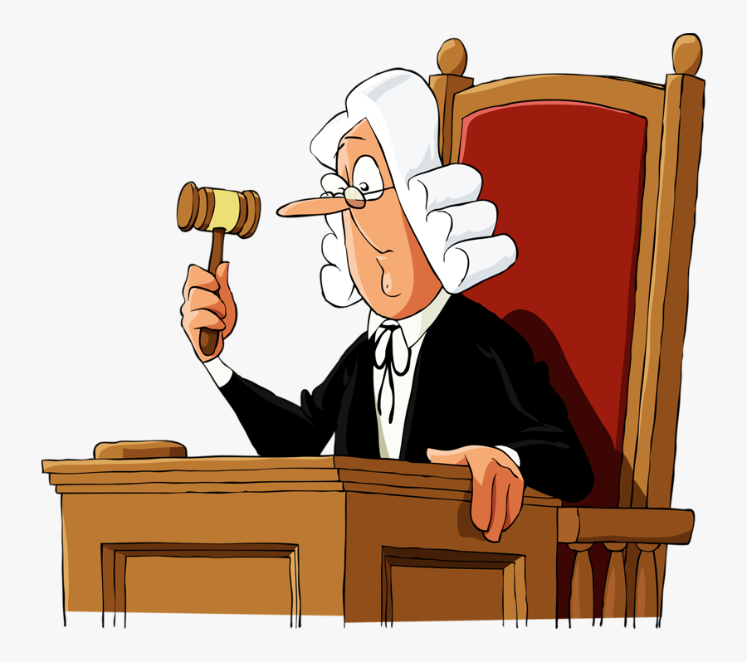
IDuring the Middle Ages, England established Common Laws in addition to Statutory Laws. King Henry II sent royal judges around the English countryside to hear and decide cases (Courts in the US did this in the early days which is why we call them ‘circuit’ courts). The King told his judges to consider past decisions from similar cases when making their rulings. The judges would travel back to London and discuss their cases to compare them with other regions of the country. The goal was to create a system of laws ‘common’ to the entire kingdom.
Establishing precedent

Common laws take into account not just Statutory Laws, but also customs and decisions earlier judges reached on similar issues. In this way, judgements wouldn’t be wildly different in each region of the country. Common laws focus on precedents- previous decisions reached by a judgement based on similar issues. If you committed Arson (criminal act of setting fire to property), and received a punishment of 5 years in prison, 6,000 dollars, Common law helped shape your punishment. That means other people who have committed similar crimes involving arson have also received a similar punishment as you in the past. If someone were to burn the same thing as you in the future, and receive 1 year probation and 3 hours of community service, that would be unfair and against Common Law practices.
Put it all together: Answer the questions using both readings
The King asked his judges to consider |  | and |  | when making their rulings

How does common law prevent judgements from being wildly different in each region?

How does common law ensure fairness in court decisions?

